|  |
| --- |
| INTERNATIONAL INSTITUTE OF INFORMation Technology Bangalore. |
| Bank Data-Warehouse Architecture for Basel III Capital Accord |
|  |
| VENKATESAN M MT2011169 |
| **Version 1.0** |
| **8/31/12** |

|  |
| --- |
| Basel III accord needs multiple reporting of data from different modules of the business to keep track of the necessary capital reserves. There is a need to align the data structures that drive risk and financial data. These are: Transactional data, Asset Data and Customer Data. Also new terms such as Liquidity coverage ratio , Leverage Ratio, Systemically Important Financial Institutions (SIFI), Capital Conservation Buffer, Counter cycle capital buffer, etc are been included In the Basel III accord. The data quality and usability of the data model must be ensured as this accord will lead to multiple data reporting across departments. Data Ware house model will enable us capture data and analyse from multiple reporting. This work will outline the components of the Banking Data Warehouse (BDW) for Basel III and how they assist financial institutions to address the data modeling and data consolidation issues relating to the Basel III Capital Accord. |

**Banking Data warehouse support for Basel III [Bank-tier architecture]**

The BDW comprises a proven, flexible and scalable data warehouse technical infrastructure to address the following business reporting and analysis needs:

* Profitability
* Relationship Marketing (CRM)
* Regulatory Compliance
* Risk
* Asset and Liability Management

The below diagram is the eight tier standard architecture defined for Basel III capital accord..

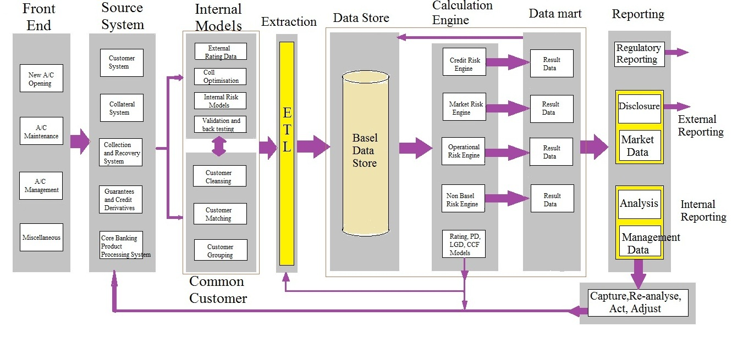

Figure : BDW end-to-end Architecture

The different layers of the BDW has been briefly summarized below

1. **Front End**

The customer and the general bank employee interact with the system for day-to day normal transactions that are to be done.

1. **Data Sources**

The data from various resources are grouped in this tier.

1. **Internal Models and Common Customer**

The internal and external sources of all data required for Basel II/III. Here the data from the data source are sanitized to make the data analysis easy in the further layers.

1. **Extraction**

The processes and technology needed to extract the data from the potentially diverse sources in an efficient and timely manner.

1. **Enterprise Data Store (The Data warehouse/storage Repository)**

The repository into which all the detailed data needed for Basel II/III is gathered.

1. **Transformation and Calculation (Stage Tables)**

The carrying out of various calculations by specialist risk applications.

1. **Data Marts (Mart Tables)**

Aggregated data for reporting and analysis.

1. **Reporting**

The creation and delivery of the Basel II/III reports to the various user groups.

Over this architecture the various Banking Data Warehouse components such as

1. Banking data Warehouse model.
2. Application solution Templates.
3. Business solution templates.
4. Project views, … and if more components needed

have to be identified and mapped on to the proposed eight tier architecture.

**Report Apparatus**

The following are the people and their qualifications working in this project.

**Venkatesan.M** M.Tech Software Engineering,

International Institute of Information Technology Bangalore.